PRESS RELEASE Naomi Knight
FOR IMMEDIATE RELEASE Maryland FFA Program Coordinator
April 18, 2024 nknight@maefonline.com
MARYLAND FFA HOLDS STATE SPRING JUDGING EVENTS
(WESTMINSTER, MARYLAND) April 13, 2024- Maryland FFA Association held its annual State Spring Judging Events at Westminster High School April 13th, with 412 FFA members registered from 34 chapters competing in one of the eleven Career Development Events. The top teams of each event will advance to represent Maryland in the competitions at the National FFA Convention.

Agricultural Technology & Mechanical Systems: 40 members representing 10 chapters
1st Team- Francis Scott Key FFA: Brenden Bosley, David Geiman, Kyle Medlin, Chase Owens
2nd Team- Walkersville: Jacob Inskeep, Tyler Martin, Hunter Mitchell, Trajan Urban
Agriscience Fair: 7 members, 6 chapters
1st in Animal Systems Division 5- Danielle Vaughn, Clear Spring FFA
2nd in Animal Systems Division 5- Alyssa Long, Cecil School of Technology FFA
1st in Env. Natural Resources Division 4- Madilyn Griffin & Adithya Bhaskaran, Parkside CTE
1st in Plant Systems Div. 6- Sarah Yamakawa & Kaitlyn Tyler, Parkside CTE FFA
Agronomy: 40 members, 8 chapters
1st Team- Walkersville: Mila Miletic, Wyatt New, Mason Saylor, Lizz Tena
2nd Team- Hereford: Adeline Gingue, Dani Lane, Brooke Leaf, Kai Troyer
Farm & Agribusiness Management: 26 members, 6 chapters
1st Team- Catoctin: Annalise Abruzzese, Kaitlynn Bentz, Alyssa Costa, Carly Ridenour
2nd Team- North Harford: Lucy Heisey, Samuel Kleback, James Ortt, William Rowan
Floriculture: 72 members, 18 chapters
1st Team- Linganore: Emma Block, Neveah Flynn, Katherine Stephens, Lily Tressler
2nd Team- Hereford: Lily Cromwell, Scarlett Heffner, Larissa Median, Nora Punte
Food Science: 24 members, 4 chapters
1st Team- Linganore: Hannah Carr, Jenna Fountain, Reagan Leader, Ella Twiford
2nd Team- Walkersville: Amira Deneau, Kaitlyn Hall, Isabel Reed, Grace Willets
Meat Evaluation: 38 members, 9 chapters
1st Team- South Carroll: Austin Bagwell, Emmalea Bartolain, Trista Christiansen, Brennon Harrison
2nd Team- North Harford: Nevada Abels, Sophia Bonincontri, Nine Field, Grayson Whaley
Middle School Ag. Challenge: 7 members, 1 chapter
1st - Stephan Lowe, Boonsboro Middle FFA
2nd- Brody Walburn, Boonsboro Middle FFA
Milk Quality & Products: 41 members, 9 chapters
1st Team- North Harford: Cole Hellwig, Madison Thomas, Emily Troyer, Katie Vanarsdale
2nd Team- Middletown: Ella Fell, Addison Kaas, Delaney Ogg, Jereamiah Sowers
Nursery/Landscape: 27 members, 6 chapters
1st Team- North Harford: Bianca Baker, Frank DeLucia, Ryan Layman, Jonathan VanBuskirk
2nd Team- Cecil Sch. of Tech.: Sara DePaola, Kaleb Graziosi, Jaren Hensley, Valeria Lopez Camacho
Veterinary Science: 80 members, 20 chapters
1st Team- Linganore: Sierra Howell, Allena Jaworski, Chloe Kelley, Hailey Pleasants
2nd Team- North Harford: Grace Bauer, Allyson Knott, Erin McGovern, Clayton McGraw

The Maryland Agricultural Education Foundation is a 501c3 non-governmental nonprofit established in 1989. Through the Maryland FFA, teacher workshops, scholarships, grants, Mobile Labs and Showcases, and revenues from the Ag Tag license plate sales, the Foundation pursues its mission to promote the understanding and appreciation of the importance of agriculture in everyone’s daily lives. The Maryland FFA Association’s staff team is partially funded through a $60,000 federal Perkins Grant facilitated by the Maryland State Department of Education. The Maryland FFA Association has 2,435 active members in 47 Chapters throughout the State. For more information, visit www.mdffa.org or contact Naomi Knight at nknight@maefonline.com

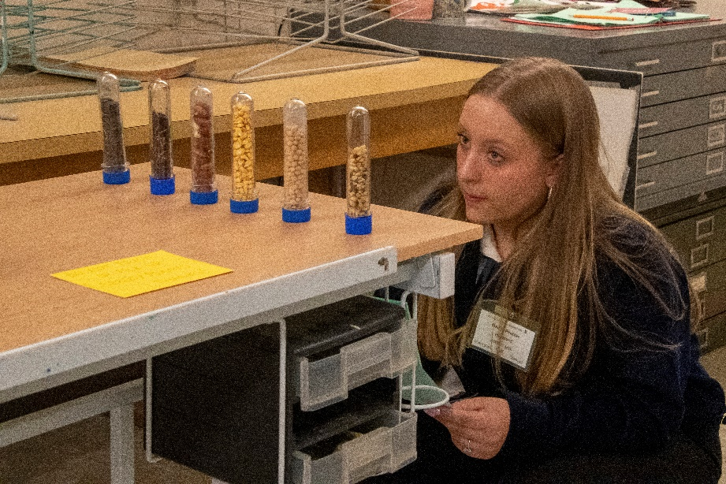

Eight teams were registered to compete in the 2024 Maryland FFA Agronomy Career
Development Event. Each contestant identifies specimens of Crops, seeds and weeds.
It is a comprehensive event covering crops, soils and pest management principles.

In the 2024 Maryland FFA Milk Quality & Products Career Development Event, nine
teams were registered to compete in evaluating the quality of milk and other dairy products.
Contestants have to understand milk production, processing, safety and sanitation.

